Sales Analysis- Case Study

- From the graph below we can conclude Brookfield have higher number of Male& Female
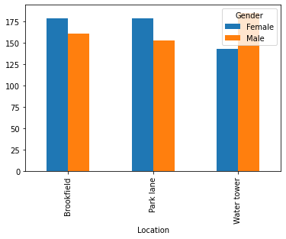

- From the plot we can conclude sales is at it’s peak on Day-15
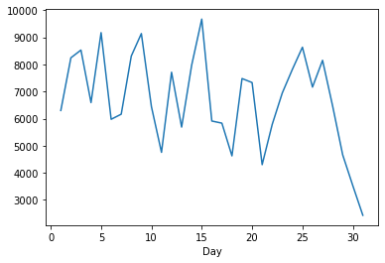

- Highest member location vs Lowest member location

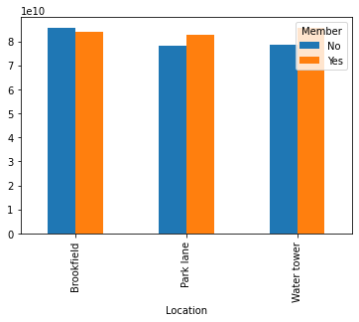

- Location with highest rating is water Tower
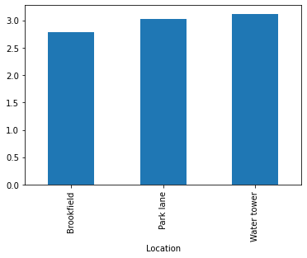

- Female spends more from the below graph
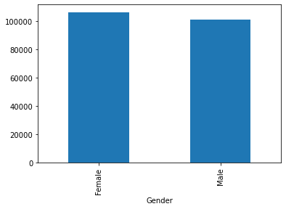
- Members spend more from the below graph reference
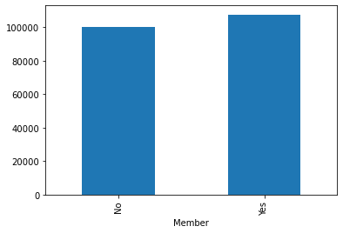

- Productline Spends more is Sporting

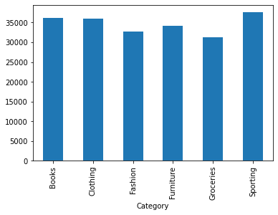

- Productline is Popular among men vs woman

